Git Hook

What is a Git Hook
# Source: AI Source: Provided by: [Data Path: Persons Table -> ID Column: 1, Name_En Column: Motasem Essam] -> From: [ChatGPT] on [3/6/2026]
A Git Hook is a script that Git automatically runs when certain events happen in a repository in Git.
It allows developers to automate tasks such as testing, formatting code, or validating commits.

Simple Idea
# Source: AI Source: Provided by: [Data Path: Persons Table -> ID Column: 1, Name_En Column: Motasem Essam] -> From: [ChatGPT] on [3/6/2026]
A hook = automatic action triggered by Git events.
Example events:
- before committing code
- after committing code
- before pushing code
- after merging branches

Where Hooks Are Stored
# Source: AI Source: Provided by: [Data Path: Persons Table -> ID Column: 1, Name_En Column: Motasem Essam] -> From: [ChatGPT] on [3/6/2026]
Git hooks are stored inside the repository in:
.git/hooks/
Example files you may see:
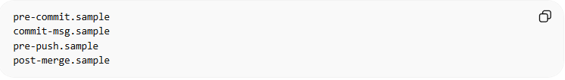
pre-commit.sample
commit-msg.sample
pre-push.sample
post-merge.sample
They are sample scripts. To use them, you remove .sample and add your script.

Common Git Hooks
Below are the most important Git Hooks used in real projects in Git.
They are divided into Client-side hooks and Server-side hooks.

1️⃣ Client-Side Hooks
# Source: AI Source: Provided by: [Data Path: Persons Table -> ID Column: 1, Name_En Column: Motasem Essam] -> From: [ChatGPT] on [3/6/2026]
These run on your local machine.

1. pre-commit
# Source: AI Source: Provided by: [Data Path: Persons Table -> ID Column: 1, Name_En Column: Motasem Essam] -> From: [ChatGPT] on [3/6/2026]
Runs before creating a commit.
Purpose: prevent bad code or enforce formatting.
Example: Run Python tests before committing.
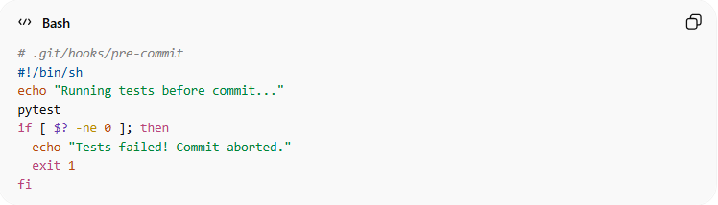
# .git/hooks/pre-commit
#!/bin/sh
echo "Running tests before commit..."
pytest
if [ $? -ne 0 ]; then
echo "Tests failed! Commit aborted."
exit 1
fi
- Make it executable:
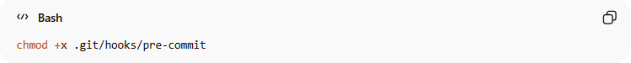
chmod +x .git/hooks/pre-commit

2. prepare-commit-msg
# Source: AI Source: Provided by: [Data Path: Persons Table -> ID Column: 1, Name_En Column: Motasem Essam] -> From: [ChatGPT] on [3/6/2026]
Runs before the commit message editor opens.
Purpose: auto-add ticket ID to commit messages.
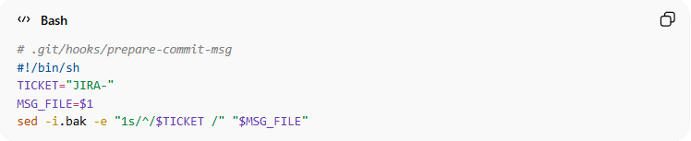
# .git/hooks/prepare-commit-msg
#!/bin/sh
TICKET="JIRA-"
MSG_FILE=$1
sed -i.bak -e "1s/^/$TICKET /" "$MSG_FILE"
- When you commit, the message starts with JIRA-.

3. commit-msg
# Source: AI Source: Provided by: [Data Path: Persons Table -> ID Column: 1, Name_En Column: Motasem Essam] -> From: [ChatGPT] on [3/6/2026]
Runs after the commit message is written.
Purpose: enforce commit message style.
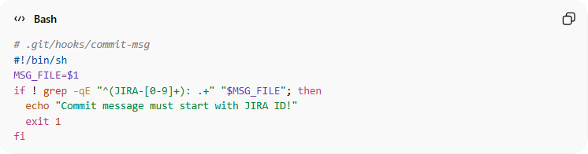
# .git/hooks/commit-msg
#!/bin/sh
MSG_FILE=$1
if ! grep -qE "^(JIRA-[0-9]+): .+" "$MSG_FILE"; then
echo "Commit message must start with JIRA ID!"
exit 1
fi
- Blocks commit if it doesn’t start with JIRA-123: style.

4. post-commit
# Source: AI Source: Provided by: [Data Path: Persons Table -> ID Column: 1, Name_En Column: Motasem Essam] -> From: [ChatGPT] on [3/6/2026]
Runs after commit is created.
Purpose: notify or log commits locally.
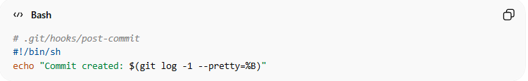
# .git/hooks/post-commit
#!/bin/sh
echo "Commit created: $(git log -1 --pretty=%B)"

5. pre-push
# Source: AI Source: Provided by: [Data Path: Persons Table -> ID Column: 1, Name_En Column: Motasem Essam] -> From: [ChatGPT] on [3/6/2026]
Runs before pushing code.
Purpose: prevent pushing broken code.
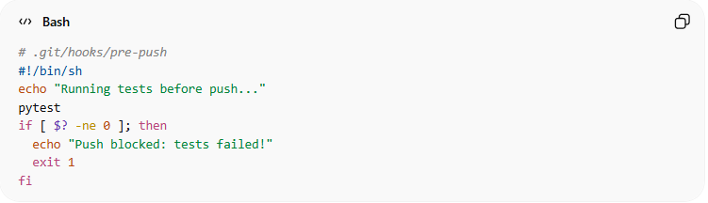
# .git/hooks/pre-push
#!/bin/sh
echo "Running tests before push..."
pytest
if [ $? -ne 0 ]; then
echo "Push blocked: tests failed!"
exit 1
fi

6. post-checkout
# Source: AI Source: Provided by: [Data Path: Persons Table -> ID Column: 1, Name_En Column: Motasem Essam] -> From: [ChatGPT] on [3/6/2026]
Runs after switching branches.
Purpose: install dependencies or update environment.
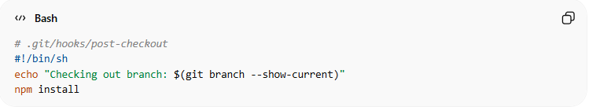
# .git/hooks/post-checkout
#!/bin/sh
echo "Checking out branch: $(git branch --show-current)"
npm install

7. post-merge
# Source: AI Source: Provided by: [Data Path: Persons Table -> ID Column: 1, Name_En Column: Motasem Essam] -> From: [ChatGPT] on [3/6/2026]
Runs after merging branches.
Purpose: rebuild project or dependencies.
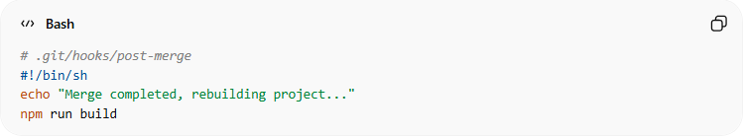
# .git/hooks/post-merge
#!/bin/sh
echo "Merge completed, rebuilding project..."
npm run build

8. pre-rebase
# Source: AI Source: Provided by: [Data Path: Persons Table -> ID Column: 1, Name_En Column: Motasem Essam] -> From: [ChatGPT] on [3/6/2026]
Runs before rebase.
Purpose: prevent dangerous rebases.
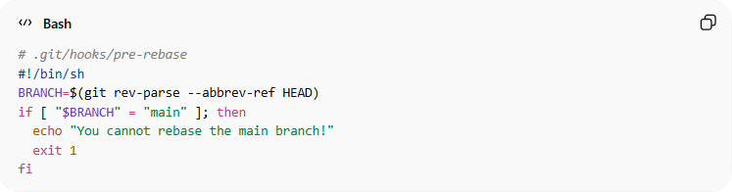
# .git/hooks/pre-rebase
#!/bin/sh
BRANCH=$(git rev-parse --abbrev-ref HEAD)
if [ "$BRANCH" = "main" ]; then
echo "You cannot rebase the main branch!"
exit 1
fi

9. pre-applypatch
# Source: AI Source: Provided by: [Data Path: Persons Table -> ID Column: 1, Name_En Column: Motasem Essam] -> From: [ChatGPT] on [3/6/2026]
Runs before applying a patch using git am.
Purpose: run checks before applying patches.
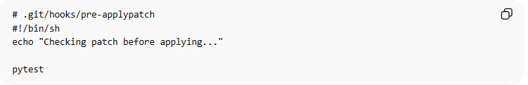
# .git/hooks/pre-applypatch
#!/bin/sh
echo "Checking patch before applying..."

pytest

10. applypatch-msg
# Source: AI Source: Provided by: [Data Path: Persons Table -> ID Column: 1, Name_En Column: Motasem Essam] -> From: [ChatGPT] on [3/6/2026]
Runs when a patch message is created.
Purpose: validate patch commit message.
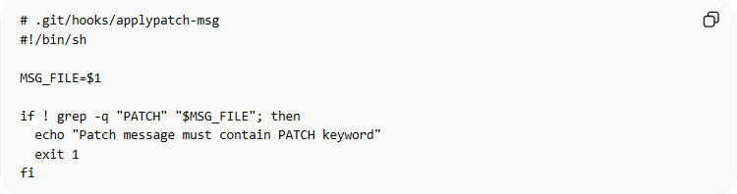
# .git/hooks/applypatch-msg
#!/bin/sh
MSG_FILE=$1
if ! grep -q "PATCH" "$MSG_FILE"; then
echo "Patch message must contain PATCH keyword"
exit 1
fi

11. pre-merge-commit
# Source: AI Source: Provided by: [Data Path: Persons Table -> ID Column: 1, Name_En Column: Motasem Essam] -> From: [ChatGPT] on [3/6/2026]
Runs before a merge commit is created.
Purpose: run checks before merge commit.
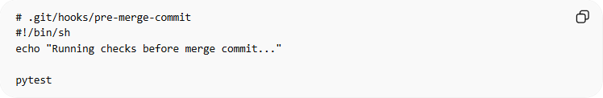
# .git/hooks/pre-merge-commit
#!/bin/sh
echo "Running checks before merge commit..."
pytest

12. sendemail-validate
# Source: AI Source: Provided by: [Data Path: Persons Table -> ID Column: 1, Name_En Column: Motasem Essam] -> From: [ChatGPT] on [3/6/2026]
Runs when using:
git send-email
Purpose: validate emails before sending patches.
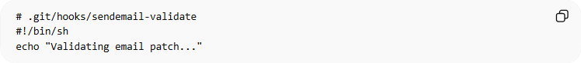
# .git/hooks/sendemail-validate
#!/bin/sh
echo "Validating email patch..."

2️⃣ Server-Side Hooks
# Source: AI Source: Provided by: [Data Path: Persons Table -> ID Column: 1, Name_En Column: Motasem Essam] -> From: [ChatGPT] on [3/6/2026]
These run on the Git server.

13. pre-receive
# Source: AI Source: Provided by: [Data Path: Persons Table -> ID Column: 1, Name_En Column: Motasem Essam] -> From: [ChatGPT] on [3/6/2026]
Runs before server accepts push.
Purpose: block forbidden commits.
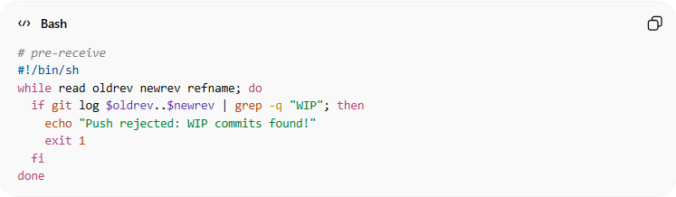
# pre-receive
#!/bin/sh
while read oldrev newrev refname; do
if git log $oldrev..$newrev | grep -q "WIP"; then
echo "Push rejected: WIP commits found!"
exit 1
fi
done

14. update
# Source: AI Source: Provided by: [Data Path: Persons Table -> ID Column: 1, Name_En Column: Motasem Essam] -> From: [ChatGPT] on [3/6/2026]
Runs for each branch pushed.
Purpose: enforce branch permissions.
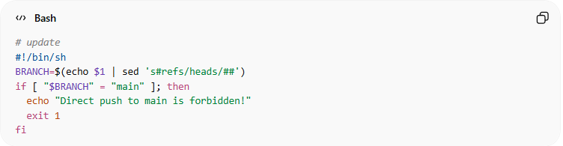
# update
#!/bin/sh
BRANCH=$(echo $1 | sed 's#refs/heads/##')
if [ "$BRANCH" = "main" ]; then
echo "Direct push to main is forbidden!"
exit 1
fi

15. post-receive
# Source: AI Source: Provided by: [Data Path: Persons Table -> ID Column: 1, Name_En Column: Motasem Essam] -> From: [ChatGPT] on [3/6/2026]
Runs after push is accepted.
Purpose: deploy automatically.
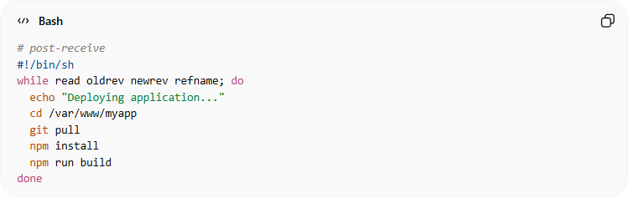
# post-receive
#!/bin/sh
while read oldrev newrev refname; do
echo "Deploying application..."
cd /var/www/myapp
git pull
npm install
npm run build
done

16. post-update
# Source: AI Source: Provided by: [Data Path: Persons Table -> ID Column: 1, Name_En Column: Motasem Essam] -> From: [ChatGPT] on [3/6/2026]
Runs after references are updated on the server.
Purpose: update services or notify systems.
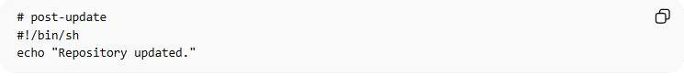
# post-update
#!/bin/sh
echo "Repository updated."

17. push-to-checkout
# Source: AI Source: Provided by: [Data Path: Persons Table -> ID Column: 1, Name_En Column: Motasem Essam] -> From: [ChatGPT] on [3/6/2026]
Runs when pushing to a checked-out branch on a remote server.
Purpose: update working tree automatically.
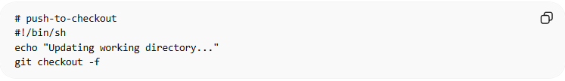
# push-to-checkout
#!/bin/sh
echo "Updating working directory..."
git checkout -f

18. fsmonitor-watchman
# Source: AI Source: Provided by: [Data Path: Persons Table -> ID Column: 1, Name_En Column: Motasem Essam] -> From: [ChatGPT] on [3/6/2026]
Runs when Git uses file system monitoring to detect file changes faster.
Purpose: improve Git performance by monitoring file system changes instead of scanning all files repeatedly.
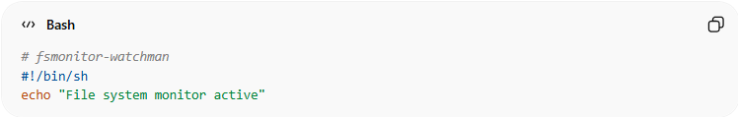
# fsmonitor-watchman
#!/bin/sh
echo "File system monitor active"

✅ Tips for all hooks:
# Source: AI Source: Provided by: [Data Path: Persons Table -> ID Column: 1, Name_En Column: Motasem Essam] -> From: [ChatGPT] on [3/6/2026]
- Save hooks inside .git/hooks/
- Make them executable:
chmod +x .git/hooks/<hook-name>
- Test hooks before relying on them.
- Use Husky or pre-commit framework to share hooks in a team.

script in Git hooks

🔹 What is script
# Source: AI Source: Provided by: [Data Path: Persons Table -> ID Column: 1, Name_En Column: Motasem Essam] -> From: [ChatGPT] on [3/6/2026]
A script in Git hooks is a small program or set of commands that Git runs automatically when a certain event occurs in your repository.
In simple terms:
Git hooks = “trigger” + “script”
The script is the action Git performs when the trigger happens.

🔹 What the script does
# Source: AI Source: Provided by: [Data Path: Persons Table -> ID Column: 1, Name_En Column: Motasem Essam] -> From: [ChatGPT] on [3/6/2026]
The script is used to automate tasks related to your repository. Some common uses include:
- Enforcing code quality
  - Run tests or linters before committing/pushing.
  - Example: prevent committing code with syntax errors.
- Validating commit messages
  - Ensure commit messages follow team conventions.
  - Example: commit must start with JIRA-123:.
- Automating repetitive tasks
  - Install dependencies after switching branches.
  - Build the project after merging.
- Preventing mistakes
  - Stop accidental commits to protected branches.
  - Block pushes with WIP (Work In Progress) commits.
- Deployment & notifications
  - Automatically deploy code after a push.
  - Send notifications after commits or merges.

🔹 How it works
# Source: AI Source: Provided by: [Data Path: Persons Table -> ID Column: 1, Name_En Column: Motasem Essam] -> From: [ChatGPT] on [3/6/2026]
- You write a script in .git/hooks/, e.g., pre-commit or pre-push.
- Git runs the script at a specific time.
- The script can:
  - Exit with 0 → Git continues the action.
  - Exit with non-zero → Git stops the action (commit, push, etc.).

🔹 Example
# Source: AI Source: Provided by: [Data Path: Persons Table -> ID Column: 1, Name_En Column: Motasem Essam] -> From: [ChatGPT] on [3/6/2026]
pre-commit hook script to run tests before committing:
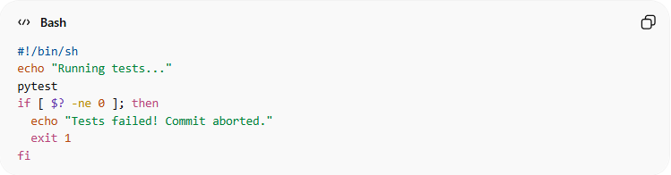
#!/bin/sh
echo "Running tests..."
pytest
if [ $? -ne 0 ]; then
echo "Tests failed! Commit aborted."
exit 1
fi
- If tests fail → commit is blocked.
- If tests pass → commit continues.

🔹 Git Hook scripting languages
# Source: AI Source: Provided by: [Data Path: Persons Table -> ID Column: 1, Name_En Column: Motasem Essam] -> From: [ChatGPT] on [3/6/2026]
Git hook scripts can be written in almost any programming or scripting language, as long as the operating system can execute them.
Here’s a breakdown:

1️⃣ Shell Scripts (Bash / sh)
# Source: AI Source: Provided by: [Data Path: Persons Table -> ID Column: 1, Name_En Column: Motasem Essam] -> From: [ChatGPT] on [3/6/2026]
- Most common on Linux/macOS.
- Works directly with Git commands.
- Example:
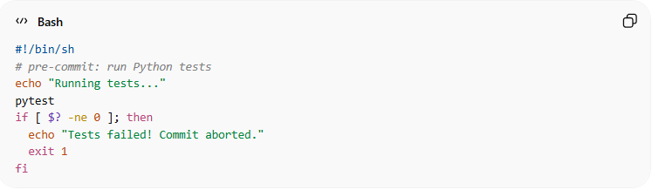
#!/bin/sh
# pre-commit: run Python tests
echo "Running tests..."
pytest
if [ $? -ne 0 ]; then
echo "Tests failed! Commit aborted."
exit 1
fi
- Make executable:
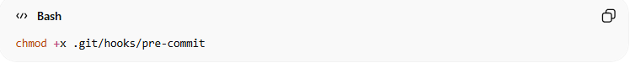
chmod +x .git/hooks/pre-commit

2️⃣ Batch Scripts (.bat / .cmd)
# Source: AI Source: Provided by: [Data Path: Persons Table -> ID Column: 1, Name_En Column: Motasem Essam] -> From: [ChatGPT] on [3/6/2026]
- Used on Windows.
- Example:
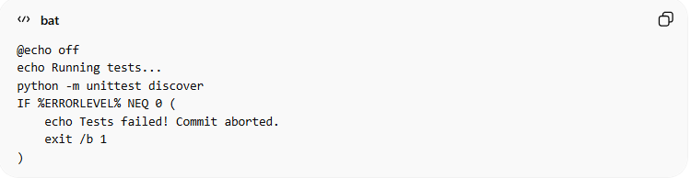
@echo off
echo Running tests...
python -m unittest discover
IF %ERRORLEVEL% NEQ 0 (
echo Tests failed! Commit aborted.
exit /b 1
)

3️⃣ Python
# Source: AI Source: Provided by: [Data Path: Persons Table -> ID Column: 1, Name_En Column: Motasem Essam] -> From: [ChatGPT] on [3/6/2026]
- Hooks can be written entirely in Python.
- Example (pre-commit):
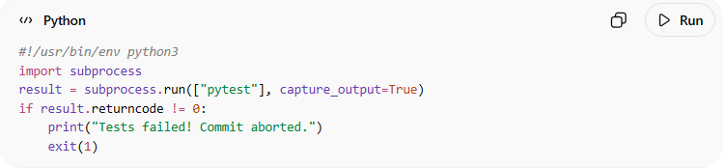
#!/usr/bin/env python3
import subprocess
result = subprocess.run(["pytest"], capture_output=True)
if result.returncode != 0:
print("Tests failed! Commit aborted.")
exit(1)
- Make executable: chmod +x .git/hooks/pre-commit

4️⃣ Perl / Ruby / Node.js
# Source: AI Source: Provided by: [Data Path: Persons Table -> ID Column: 1, Name_En Column: Motasem Essam] -> From: [ChatGPT] on [3/6/2026]
- Any language with executable scripts works.
- Examples:
Node.js pre-commit
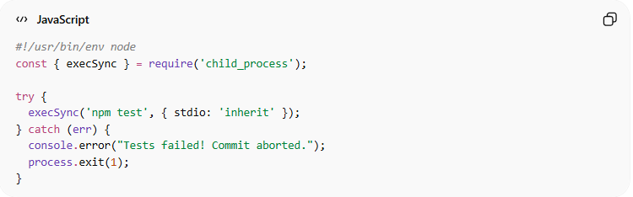
#!/usr/bin/env node
const { execSync } = require('child_process');

try {
execSync('npm test', { stdio: 'inherit' });
} catch (err) {
console.error("Tests failed! Commit aborted.");
process.exit(1);
}
Ruby post-merge
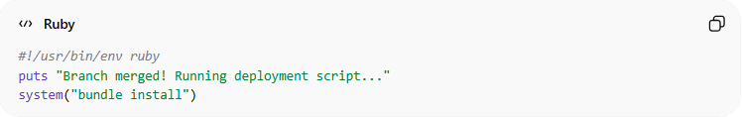
#!/usr/bin/env ruby
puts "Branch merged! Running deployment script..."
system("bundle install")

✅ Key Points
# Source: AI Source: Provided by: [Data Path: Persons Table -> ID Column: 1, Name_En Column: Motasem Essam] -> From: [ChatGPT] on [3/6/2026]
- Hook language choice depends on:
  - OS
  - Tools used in your project
  - Team preference
- Hook scripts must be executable.
- You can even use Docker or other commands if your team standardizes it.

✅ In short:
# Source: AI Source: Provided by: [Data Path: Persons Table -> ID Column: 1, Name_En Column: Motasem Essam] -> From: [ChatGPT] on [3/6/2026]
The script is what actually does the work. The hook is just the trigger point.

Why Developers Use Hooks
# Source: AI Source: Provided by: [Data Path: Persons Table -> ID Column: 1, Name_En Column: Motasem Essam] -> From: [ChatGPT] on [3/6/2026]
Git hooks help to:
- enforce code quality
- automate tests
- ensure commit standards
- prevent bad code from being pushed

Important Note
# Source: AI Source: Provided by: [Data Path: Persons Table -> ID Column: 1, Name_En Column: Motasem Essam] -> From: [ChatGPT] on [3/6/2026]
Hooks are local only.
They:
- exist only on your machine
- are not pushed to remote repositories
Teams often use tools like:
- Husky
- pre-commit frameworks
to share hook rules across developers.

Husky and pre-commit Frameworks: Automating Git Hooks

1️⃣ Husky
# Source: AI Source: Provided by: [Data Path: Persons Table -> ID Column: 1, Name_En Column: Motasem Essam] -> From: [ChatGPT] on [3/6/2026]
Husky is a JavaScript/Node.js tool that helps you manage Git hooks in your project.
🔹 Key Points
- Instead of manually creating .git/hooks/pre-commit, Husky lets you define hooks in package.json or config files.
- Works for Node.js, React, or any project using npm/yarn.
- Makes hooks version-controlled, so the whole team shares the same hooks.
🔹 Example: Pre-commit Hook with Husky
- Install Husky:
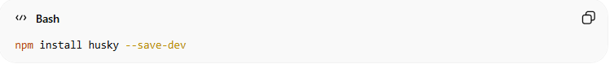
npm install husky --save-dev
- Enable Git hooks:
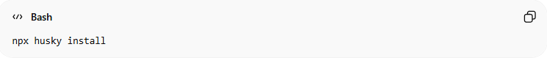
npx husky install
- Add a pre-commit hook to run tests:
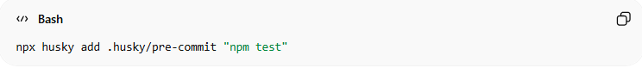
npx husky add .husky/pre-commit "npm test"
Now every commit runs npm test.
If tests fail → commit is blocked.

2️⃣ pre-commit Framework
# Source: AI Source: Provided by: [Data Path: Persons Table -> ID Column: 1, Name_En Column: Motasem Essam] -> From: [ChatGPT] on [3/6/2026]
pre-commit is a Python-based framework that helps manage Git hooks in any language.
🔹 Key Points
- Designed for Python projects, but supports other languages too.
- Hooks are defined in a .pre-commit-config.yaml file.
- Team members can install hooks with one command, so everyone uses the same rules.
🔹 Example: Python pre-commit Hook
- Install pre-commit:
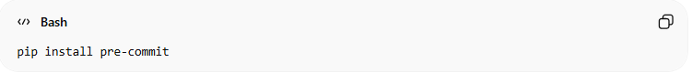
pip install pre-commit
- Create .pre-commit-config.yaml:
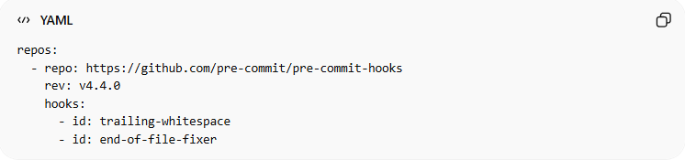
repos:
- repo: https://github.com/pre-commit/pre-commit-hooks
rev: v4.4.0
hooks:
- id: trailing-whitespace
- id: end-of-file-fixer
- Install hooks in Git:
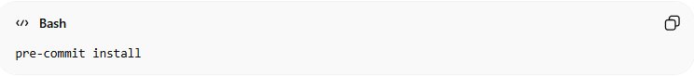
pre-commit install
Now every commit automatically:
- Removes trailing whitespace
- Ensures file ends with newline

Why Teams Use These Tools
# Source: AI Source: Provided by: [Data Path: Persons Table -> ID Column: 1, Name_En Column: Motasem Essam] -> From: [ChatGPT] on [3/6/2026]
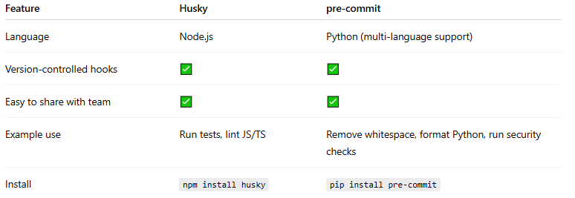
Feature | Husky | pre-commit
Language | Node.js | Python (multi-language support)
Version-controlled hooks | ✅ | ✅
Easy to share with team | ✅ | ✅
Example use | Run tests, lint JS/TS | Remove whitespace, format Python, run security checks
Install | npm install husky | pip install pre-commit

✅ Summary
# Source: AI Source: Provided by: [Data Path: Persons Table -> ID Column: 1, Name_En Column: Motasem Essam] -> From: [ChatGPT] on [3/6/2026]
- Husky → Node.js / JS projects, great for JS/React/TS codebases
- pre-commit → Python-first, but can run scripts in any language
- Both replace manual .git/hooks/ scripts and make hooks shareable across teams.

What Companies Usually Use
# Source: AI Source: Provided by: [Data Path: Persons Table -> ID Column: 1, Name_En Column: Motasem Essam] -> From: [ChatGPT] on [3/6/2026]
Most teams combine these:
- Run tests
- Lint code
- Format check
- Secret scanning
- Large file detection
- Check Commit Message
- Prevent Debug Code
- Check TODO Comments
- Dependency Security Scan
These are often managed using tools like:
- Husky
- pre-commit framework
- lint-staged

Full step-by-step Normal Test Automation Example
# Source: AI Source: Provided by: [Data Path: Persons Table -> ID Column: 1, Name_En Column: Motasem Essam] -> From: [ChatGPT] on [3/6/2026]
Absolutely! Let’s create a full step-by-step example where we test a Git hook locally. We’ll use a pre-commit hook that runs a test before committing, which is one of the most common hooks.
This works on Windows, Linux, or macOS, using Bash (or Git Bash on Windows).

Step 1️⃣ – Create a Test Repository
# Source: AI Source: Provided by: [Data Path: Persons Table -> ID Column: 1, Name_En Column: Motasem Essam] -> From: [ChatGPT] on [3/6/2026]
Open your terminal:
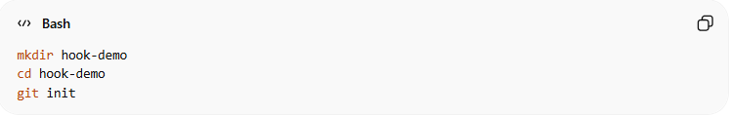
mkdir hook-demo
cd hook-demo
git init
This creates a new Git repository.

Step 2️⃣ – Create a Simple Program
# Source: AI Source: Provided by: [Data Path: Persons Table -> ID Column: 1, Name_En Column: Motasem Essam] -> From: [ChatGPT] on [3/6/2026]
Create a Python file app.py:
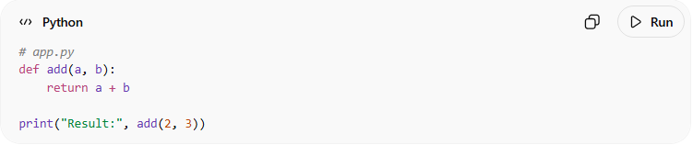
# app.py
def add(a, b):
return a + b

print("Result:", add(2, 3))
Add and commit it:
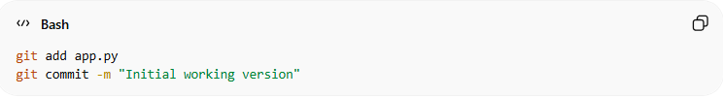
git add app.py
git commit -m "Initial working version"

Step 3️⃣ – Add a Test File
# Source: AI Source: Provided by: [Data Path: Persons Table -> ID Column: 1, Name_En Column: Motasem Essam] -> From: [ChatGPT] on [3/6/2026]
Create a simple test using Python unittest:
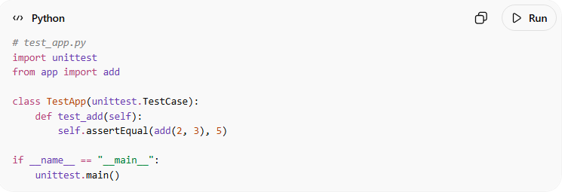
# test_app.py
import unittest
from app import add

class TestApp(unittest.TestCase):
def test_add(self):
self.assertEqual(add(2, 3), 5)

if __name__ == "__main__":
unittest.main()
Make sure it passes:
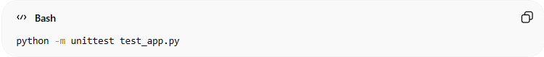
python -m unittest test_app.py
You should see:
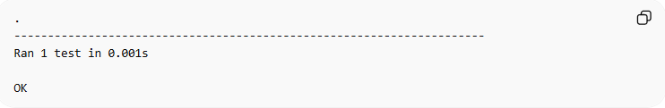
.
----------------------------------------------------------------------
Ran 1 test in 0.001s

OK

Step 4️⃣ – Create a Pre-commit Hook
# Source: AI Source: Provided by: [Data Path: Persons Table -> ID Column: 1, Name_En Column: Motasem Essam] -> From: [ChatGPT] on [3/6/2026]
Go to the .git/hooks/ folder:
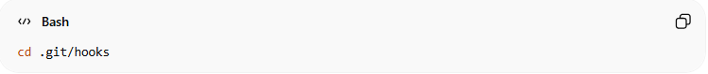
cd .git/hooks
Create a file named pre-commit:
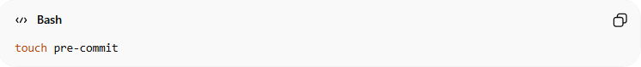
touch pre-commit
Open it in a text editor and add:
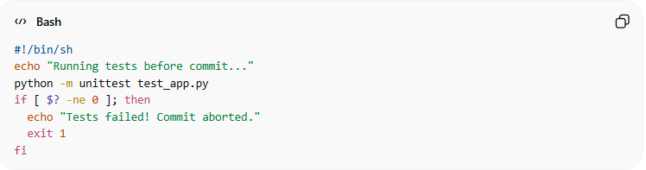
#!/bin/sh
echo "Running tests before commit..."
python -m unittest test_app.py
if [ $? -ne 0 ]; then
echo "Tests failed! Commit aborted."
exit 1
fi

What it does:
- Runs automatically before each commit.
- Prints a message.
- Runs test_app.py tests.
- If tests fail, blocks the commit.
- If tests pass, commit proceeds.
✅ It ensures you don’t commit broken code.

Step 5️⃣ – Make the Hook Executable
# Source: AI Source: Provided by: [Data Path: Persons Table -> ID Column: 1, Name_En Column: Motasem Essam] -> From: [ChatGPT] on [3/6/2026]
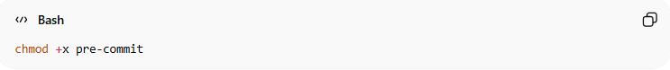
chmod +x pre-commit
Explain:
- chmod → change file permissions
- +x → make the file executable
- pre-commit → the hook script file
✅ Effect: Git can now run the pre-commit hook automatically before commits.

Step 6️⃣ – Test the Hook
# Source: AI Source: Provided by: [Data Path: Persons Table -> ID Column: 1, Name_En Column: Motasem Essam] -> From: [ChatGPT] on [3/6/2026]
- Modify the test to fail or pass.
- Observe how the hook prevents bad commits automatically.
- You can extend the hook to lint code, check formatting, or scan for secrets.

1️⃣ Make the Tests Fail
# Source: AI Source: Provided by: [Data Path: Persons Table -> ID Column: 1, Name_En Column: Motasem Essam] -> From: [ChatGPT] on [3/6/2026]
- Open your app.py file.
- Introduce a small change that will break the test.
Example:
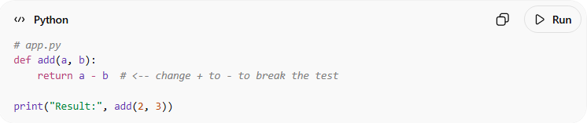
# app.py
def add(a, b):
return a - b # <-- change + to - to break the test

print("Result:", add(2, 3))
This will make the test in test_app.py fail, because add(2,3) no longer returns 5.
- Stage your change:
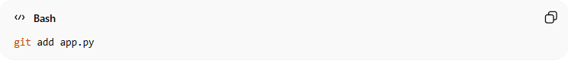
git add app.py
- Try to commit:
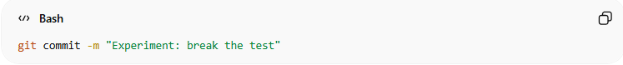
git commit -m "Experiment: break the test"
- Observe the output:
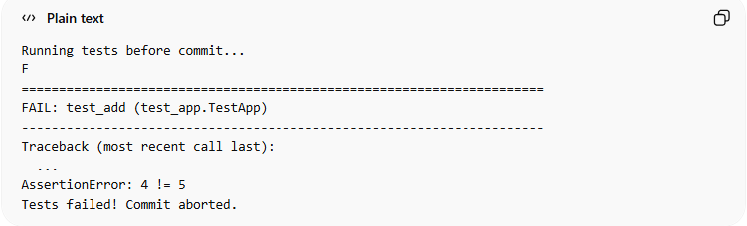
Running tests before commit...
F
======================================================================
FAIL: test_add (test_app.TestApp)
----------------------------------------------------------------------
Traceback (most recent call last):
...
AssertionError: 4 != 5
Tests failed! Commit aborted.
✅ Notice how Git prevented the commit automatically.

2️⃣ Make the Tests Pass
# Source: AI Source: Provided by: [Data Path: Persons Table -> ID Column: 1, Name_En Column: Motasem Essam] -> From: [ChatGPT] on [3/6/2026]
- Revert your change in app.py to make the test pass again:
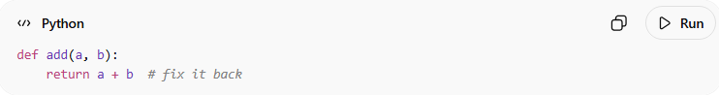
def add(a, b):
return a + b # fix it back
- Stage the file:
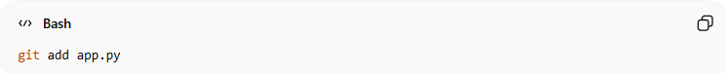
git add app.py
- Try to commit again:
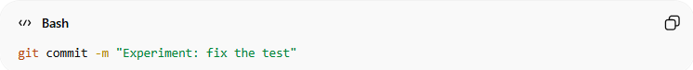
git commit -m "Experiment: fix the test"
- This time the test passes:
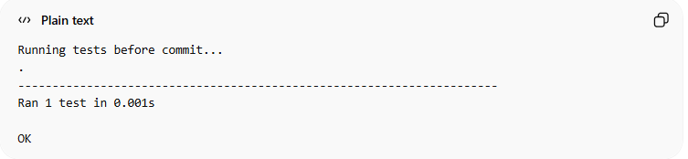
Running tests before commit...
.
----------------------------------------------------------------------
Ran 1 test in 0.001s

OK
✅ Git allows the commit because all tests passed.

✅ Result of Step 6
# Source: AI Source: Provided by: [Data Path: Persons Table -> ID Column: 1, Name_En Column: Motasem Essam] -> From: [ChatGPT] on [3/6/2026]
- The hook automatically blocks commits that fail tests or violate rules.
- When tests or checks pass, commits succeed.
- You can experiment by breaking or fixing code to see the hook enforce rules.

✅ Result
# Source: AI Source: Provided by: [Data Path: Persons Table -> ID Column: 1, Name_En Column: Motasem Essam] -> From: [ChatGPT] on [3/6/2026]
You now have a working pre-commit hook:
- Runs automatically on commit
- Prevents committing broken code
- Runs tests before every commit

Full step-by-step Husky Test Automation Example
# Source: AI Source: Provided by: [Data Path: Persons Table -> ID Column: 1, Name_En Column: Motasem Essam] -> From: [ChatGPT] on [3/6/2026]
Absolutely! Here’s a full step-by-step example using Husky to automate tests with Git hooks. This works well in Node.js / JavaScript projects, but the concept is similar to Python or other languages.

Step 1️⃣ – Create a Project
# Source: AI Source: Provided by: [Data Path: Persons Table -> ID Column: 1, Name_En Column: Motasem Essam] -> From: [ChatGPT] on [3/6/2026]

Step 1:
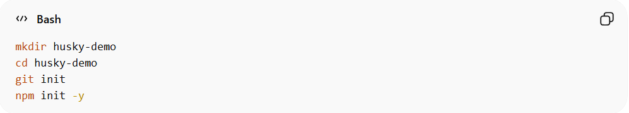
mkdir husky-demo
cd husky-demo
git init
npm init -y
Explain:
- Creates a new folder and a Node.js project.
- git init creates the .git folder so the repository is ready for Husky hooks.
- npm init -y sets up package.json automatically.

Step 2️⃣ – Install Husky
# Source: AI Source: Provided by: [Data Path: Persons Table -> ID Column: 1, Name_En Column: Motasem Essam] -> From: [ChatGPT] on [3/6/2026]
Step 2:
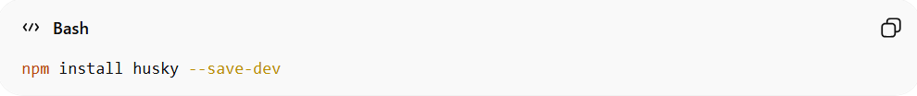
npm install husky --save-dev
Explain:
- Installs Husky as a development dependency.
- Husky allows you to add Git hooks easily on any platform.

Step 3️⃣ – Enable Husky
# Source: AI Source: Provided by: [Data Path: Persons Table -> ID Column: 1, Name_En Column: Motasem Essam] -> From: [ChatGPT] on [3/6/2026]
Step 3:
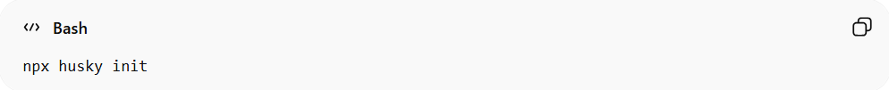
npx husky init
Explain:
- Creates the .husky folder
- Creates a default pre-commit hook
- Adds a prepare script inside package.json
Example package.json change:
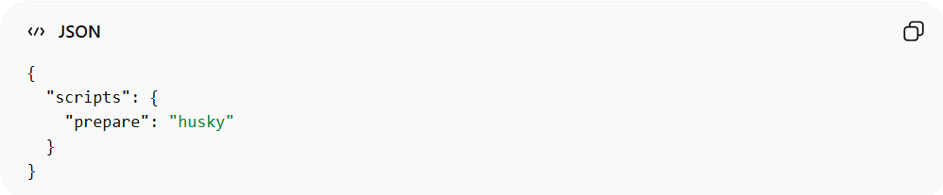
{
"scripts": {
"prepare": "husky"
}
}

Step 4️⃣ – Install a Test Framework
# Source: AI Source: Provided by: [Data Path: Persons Table -> ID Column: 1, Name_En Column: Motasem Essam] -> From: [ChatGPT] on [3/6/2026]
Step 4:
Install Jest:
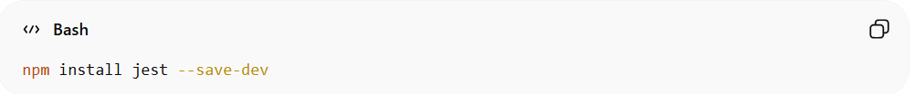
npm install jest --save-dev
Explain:
- After installing Jest, you must update the test script in package.json, because the default script created by npm init intentionally fails.
- The default script looks like this:
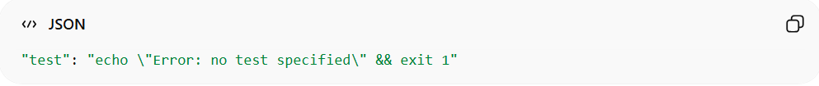
"test": "echo \"Error: no test specified\" && exit 1"
Replace it with:
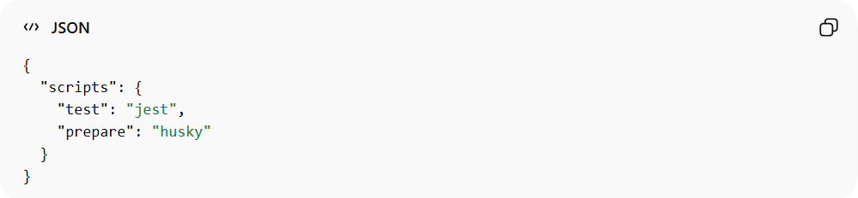
{
"scripts": {
"test": "jest",
"prepare": "husky"
}
}

What this does
- "test": "jest" → runs Jest tests when npm test is executed
- "prepare": "husky" → ensures Husky installs Git hooks automatically
- Jest will run automated tests.
- Husky will execute npm test before commits.

Step 5️⃣ Create a Simple Test
# Source: AI Source: Provided by: [Data Path: Persons Table -> ID Column: 1, Name_En Column: Motasem Essam] -> From: [ChatGPT] on [3/6/2026]
Step 5:
Create a file:
sum.test.js

You can create it using:
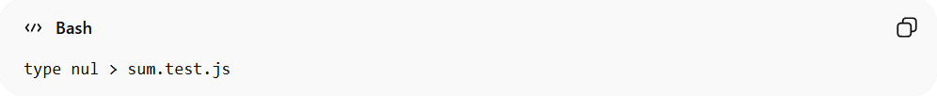
type nul > sum.test.js

Add the following code:
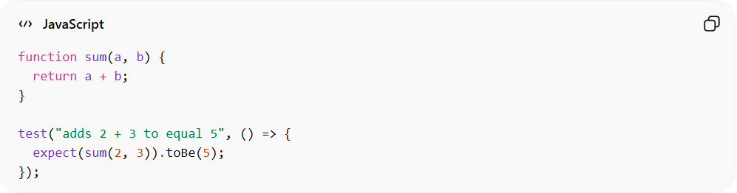
function sum(a, b) {
return a + b;
}
test("adds 2 + 3 to equal 5", () => {
expect(sum(2, 3)).toBe(5);
});
Explain:
- Defines a simple function.
- Tests if 2 + 3 = 5.

Step 6️⃣ Configure the Pre-commit Hook
# Source: AI Source: Provided by: [Data Path: Persons Table -> ID Column: 1, Name_En Column: Motasem Essam] -> From: [ChatGPT] on [3/6/2026]
Step 6:
Open the file:
.husky/pre-commit
Replace its contents with:
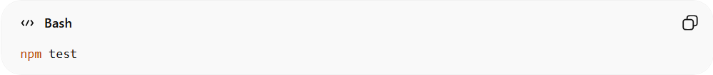
npm test
Explain:
Every time you run:
git commit
Husky will run:
npm test
before the commit is allowed.

Step 7️⃣ – Experiment (Fail and Pass Tests)

1️⃣ Make the Tests Fail
# Source: AI Source: Provided by: [Data Path: Persons Table -> ID Column: 1, Name_En Column: Motasem Essam] -> From: [ChatGPT] on [3/6/2026]
- Open your test or source file (sum.js if separate, or modify the sum function directly).
- Introduce a small change to break the test:
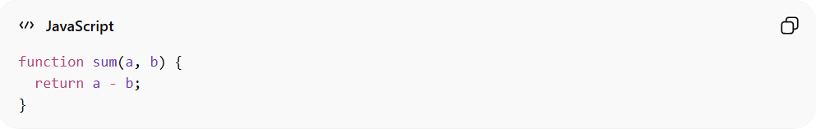
function sum(a, b) {
return a - b; // intentional bug
}
- Stage your change:
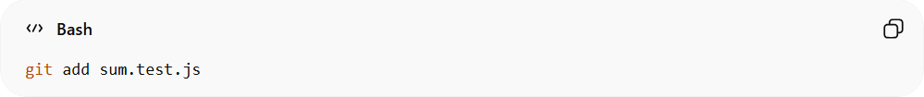
git add sum.test.js
- Try to commit:
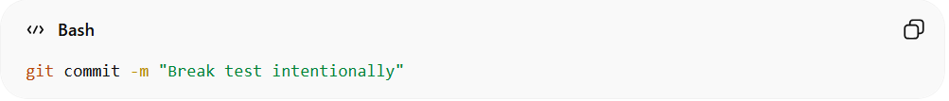
git commit -m "Break test intentionally"
Result: Husky runs npm test, the test fails, and the commit is blocked.

2️⃣ Make the Tests Pass
# Source: AI Source: Provided by: [Data Path: Persons Table -> ID Column: 1, Name_En Column: Motasem Essam] -> From: [ChatGPT] on [3/6/2026]
- Fix your code:
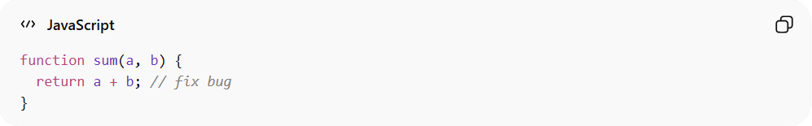
function sum(a, b) {
return a + b; // fix bug
}
- Stage the file:
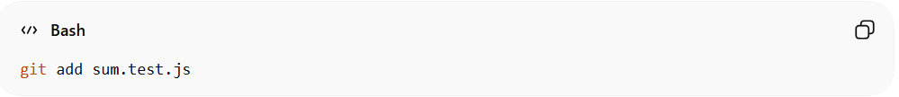
git add sum.test.js
- Try to commit again:
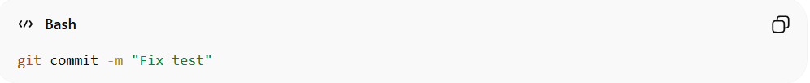
git commit -m "Fix test"
Result: Husky runs npm test, the test passes, and the commit succeeds.

✅ Result
- Husky automatically runs tests before committing.
- Commits that fail tests are blocked.

Full Step-by-Step pre-commit Framework Test Automation Example
# Source: AI Source: Provided by: [Data Path: Persons Table -> ID Column: 1, Name_En Column: Motasem Essam] -> From: [ChatGPT] on [3/6/2026]
Below is the equivalent tutorial using the Python pre-commit framework instead of Husky.
It achieves the same goal: run automated checks before every commit.
This uses pre-commit, which is commonly used in Python projects.

This example shows how to use pre-commit with Git to run tests automatically before commits.

Step 1️⃣ – Create a Project
# Source: AI Source: Provided by: [Data Path: Persons Table -> ID Column: 1, Name_En Column: Motasem Essam] -> From: [ChatGPT] on [3/6/2026]
Step 1
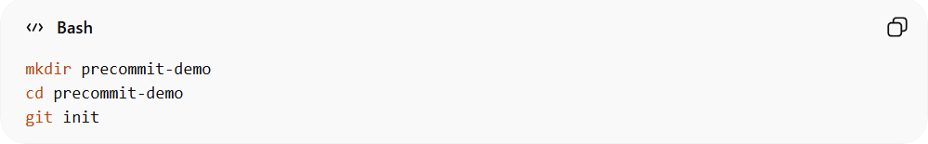
mkdir precommit-demo
cd precommit-demo
git init
Explain
- mkdir precommit-demo → creates a project folder
- cd precommit-demo → enters the folder
- git init → creates the .git repository so Git hooks can run

Step 2️⃣ – Install the pre-commit Framework
# Source: AI Source: Provided by: [Data Path: Persons Table -> ID Column: 1, Name_En Column: Motasem Essam] -> From: [ChatGPT] on [3/6/2026]
Step 2
Install pre-commit using pip:
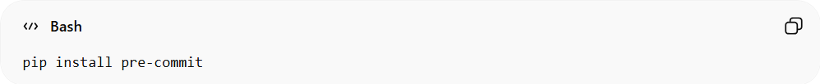
pip install pre-commit
Explain
- Installs the pre-commit framework
- This tool manages Git hooks automatically
- Hooks are configured using a configuration file

Step 3️⃣ – Create the pre-commit Configuration File
# Source: AI Source: Provided by: [Data Path: Persons Table -> ID Column: 1, Name_En Column: Motasem Essam] -> From: [ChatGPT] on [3/6/2026]
Step 3
Create a configuration file:
.pre-commit-config.yaml
Example configuration:
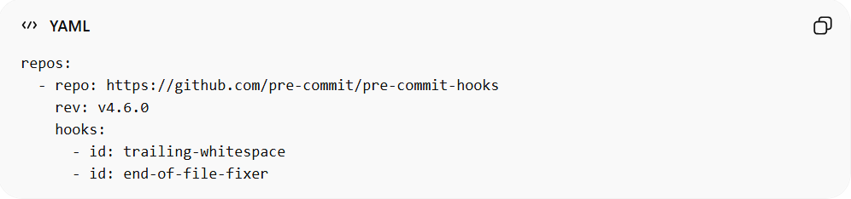
repos:
- repo: https://github.com/pre-commit/pre-commit-hooks
rev: v4.6.0
hooks:
- id: trailing-whitespace
- id: end-of-file-fixer
Explain
This file defines which hooks will run.
Example hooks:
- remove trailing whitespace
- fix missing newline at end of files

Step 4️⃣ – Install the Git Hook
# Source: AI Source: Provided by: [Data Path: Persons Table -> ID Column: 1, Name_En Column: Motasem Essam] -> From: [ChatGPT] on [3/6/2026]
Step 4
Run:
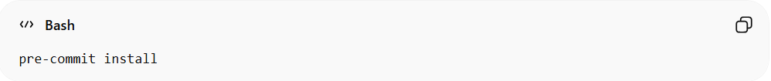
pre-commit install
Explain
This command:
- installs the Git pre-commit hook
- connects Git commits to the pre-commit framework
Now every time you run:
git commit
pre-commit will run the configured hooks.

Step 5️⃣ – Create a Simple Python Test
# Source: AI Source: Provided by: [Data Path: Persons Table -> ID Column: 1, Name_En Column: Motasem Essam] -> From: [ChatGPT] on [3/6/2026]
Create a file:
test_sum.py
Add the following code:
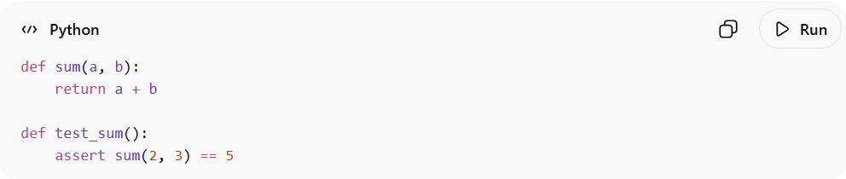
def sum(a, b):
return a + b

def test_sum():
assert sum(2, 3) == 5
Explain
This file:
- defines a function
- verifies the result using a test

Step 6️⃣ – Add a Test Hook
# Source: AI Source: Provided by: [Data Path: Persons Table -> ID Column: 1, Name_En Column: Motasem Essam] -> From: [ChatGPT] on [3/6/2026]
Edit .pre-commit-config.yaml and add a local hook:
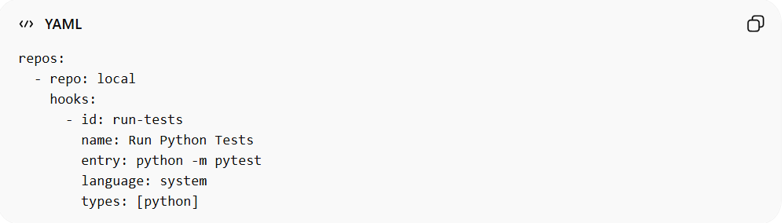
repos:
- repo: local
hooks:
- id: run-tests
name: Run Python Tests
entry: python -m pytest
language: system
types: [python]
Explain
This hook:
- runs Python tests before committing
- blocks commits if tests fail

Step 7️⃣ – Install Test Tools
# Source: AI Source: Provided by: [Data Path: Persons Table -> ID Column: 1, Name_En Column: Motasem Essam] -> From: [ChatGPT] on [3/6/2026]
Install pytest:
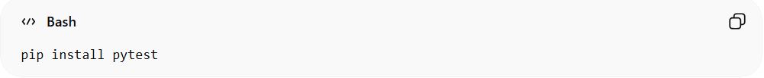
pip install pytest
Run tests manually:
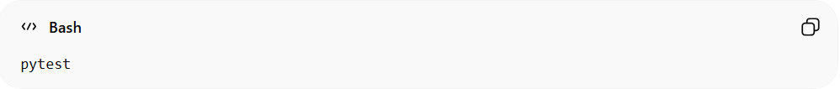
pytest
If successful you should see:
1 passed

Step 8️⃣ – Experiment (Fail and Pass Tests)

1️⃣ Make the Tests Fail
# Source: AI Source: Provided by: [Data Path: Persons Table -> ID Column: 1, Name_En Column: Motasem Essam] -> From: [ChatGPT] on [3/6/2026]
Modify the function:
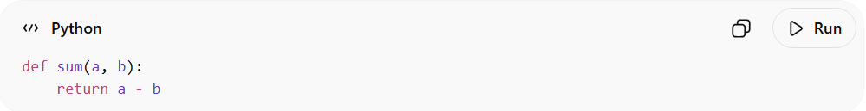
def sum(a, b):
return a - b
Stage the file:
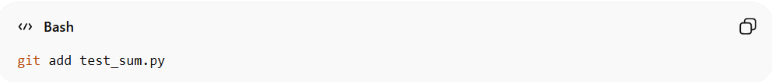
git add test_sum.py
Try committing:
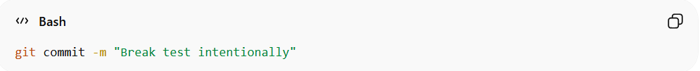
git commit -m "Break test intentionally"
Result
pre-commit runs:
pytest
The test fails → commit is blocked.

2️⃣ Make the Tests Pass
# Source: AI Source: Provided by: [Data Path: Persons Table -> ID Column: 1, Name_En Column: Motasem Essam] -> From: [ChatGPT] on [3/6/2026]
Fix the function:
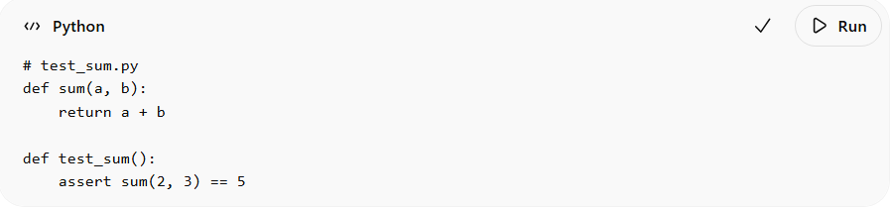
# test_sum.py
def sum(a, b):
return a + b

def test_sum():
assert sum(2, 3) == 5
Stage the file again:
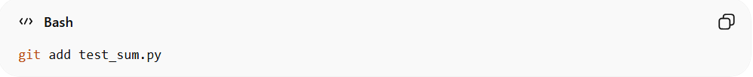
git add test_sum.py
Commit:
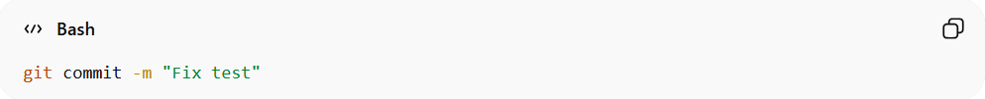
git commit -m "Fix test"
Result
- Tests pass
- Commit succeeds

✅ Result
# Source: AI Source: Provided by: [Data Path: Persons Table -> ID Column: 1, Name_En Column: Motasem Essam] -> From: [ChatGPT] on [3/6/2026]
You now have automated testing before commits.
Workflow:
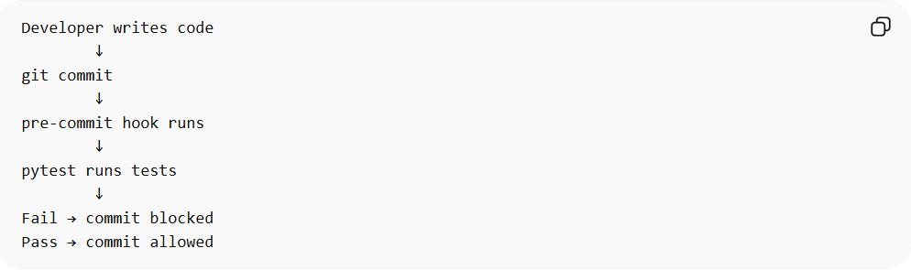
Developer writes code
↓
git commit
↓
pre-commit hook runs
↓
pytest runs tests
↓
Fail → commit blocked
Pass → commit allowed

✅ Benefits
# Source: AI Source: Provided by: [Data Path: Persons Table -> ID Column: 1, Name_En Column: Motasem Essam] -> From: [ChatGPT] on [3/6/2026]
- prevents committing broken code
- enforces code quality automatically
- widely used in Python projects

Example

Full step-by-step Normal Test Automation Example

Step 1️⃣ – Create a Test Repository
# Source: ScreenShots Source: Provided by: [Persons Table -> ID Column: 1, Name_En Column: Motasem Essam] -> Tool: [Lightshot Program] -> From [Operating System: Windows] on [3/6/2026]
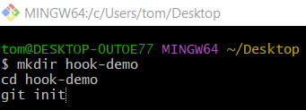
mkdir hook-demo
cd hook-demo
git init
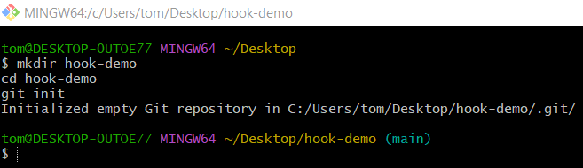

Step 2️⃣ – Create a Simple Program
# Source: ScreenShots Source: Provided by: [Persons Table -> ID Column: 1, Name_En Column: Motasem Essam] -> Tool: [Lightshot Program] -> From [Operating System: Windows] on [3/6/2026]
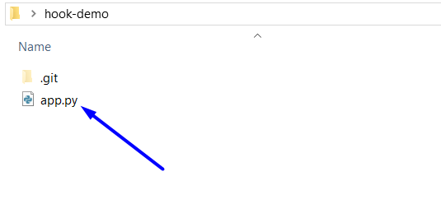
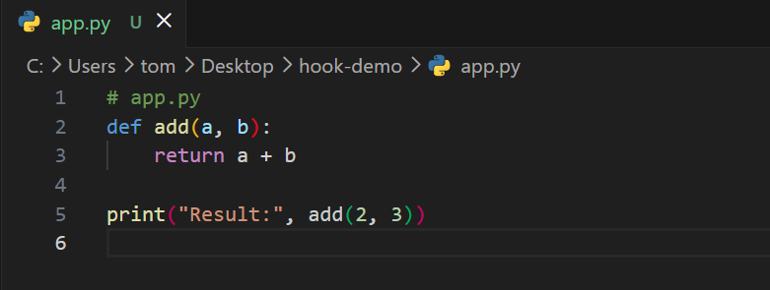
# app.py
def add(a, b):
return a + b

print("Result:", add(2, 3))
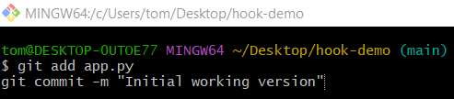
git add app.py
git commit -m "Initial working version"
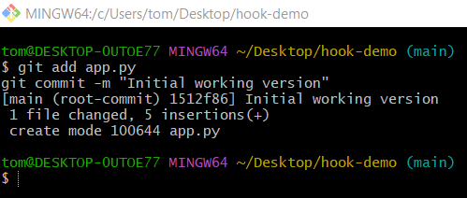

Step 3️⃣ – Add a Test File
# Source: ScreenShots Source: Provided by: [Persons Table -> ID Column: 1, Name_En Column: Motasem Essam] -> Tool: [Lightshot Program] -> From [Operating System: Windows] on [3/6/2026]
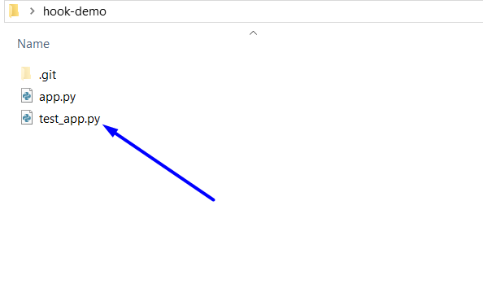
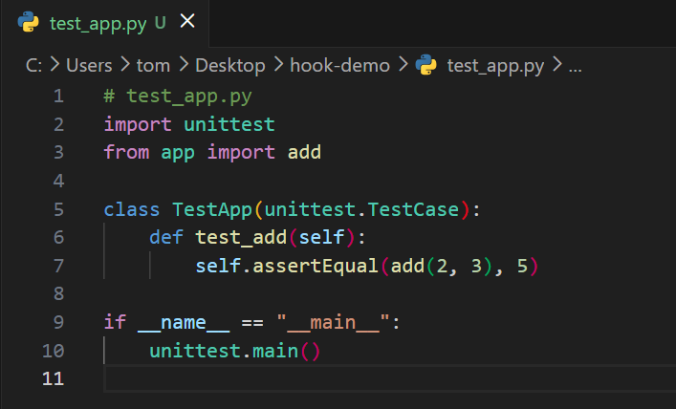
# test_app.py
import unittest
from app import add

class TestApp(unittest.TestCase):
def test_add(self):
self.assertEqual(add(2, 3), 5)

if __name__ == "__main__":
unittest.main()

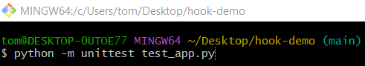
python -m unittest test_app.py
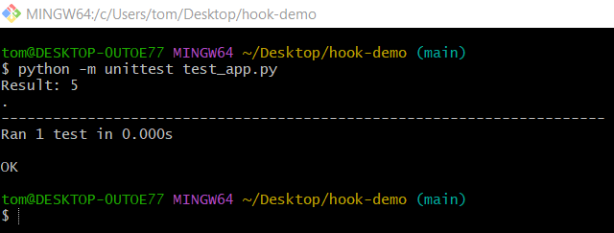

Step 4️⃣ – Create a Pre-commit Hook
# Source: ScreenShots Source: Provided by: [Persons Table -> ID Column: 1, Name_En Column: Motasem Essam] -> Tool: [Lightshot Program] -> From [Operating System: Windows] on [3/6/2026]
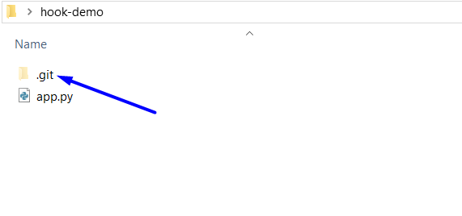
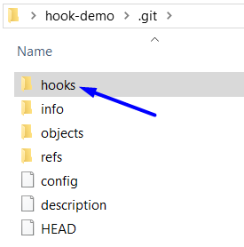
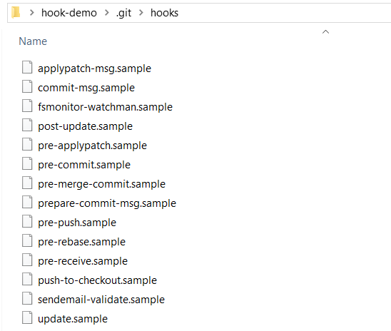
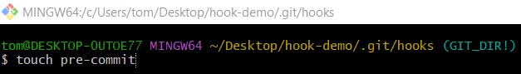
touch pre-commit
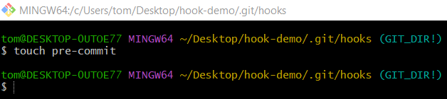
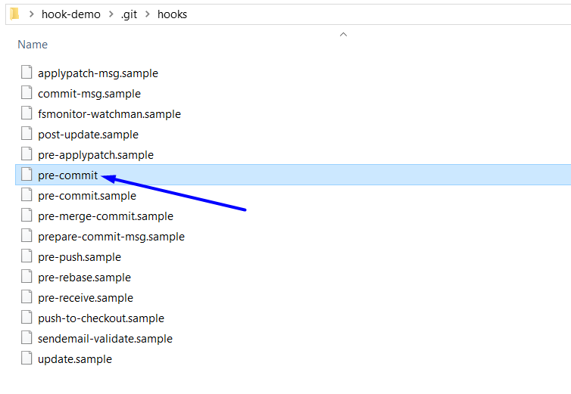
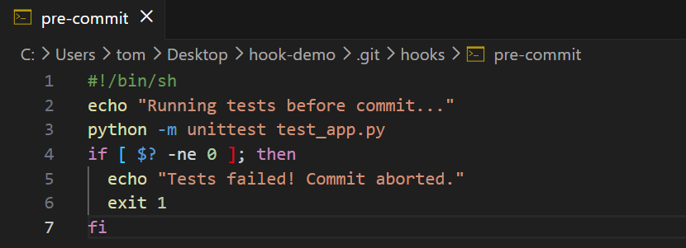
#!/bin/sh
echo "Running tests before commit..."
python -m unittest test_app.py
if [ $? -ne 0 ]; then
echo "Tests failed! Commit aborted."
exit 1
fi

Step 5️⃣ – Make the Hook Executable
# Source: ScreenShots Source: Provided by: [Persons Table -> ID Column: 1, Name_En Column: Motasem Essam] -> Tool: [Lightshot Program] -> From [Operating System: Windows] on [3/6/2026]
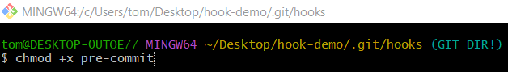
chmod +x pre-commit
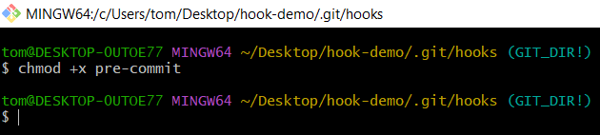

Step 6️⃣ – Test the Hook

1️⃣ Make the Tests Fail
# Source: ScreenShots Source: Provided by: [Persons Table -> ID Column: 1, Name_En Column: Motasem Essam] -> Tool: [Lightshot Program] -> From [Operating System: Windows] on [3/6/2026]
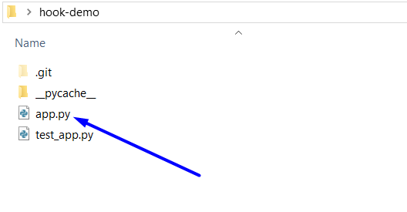
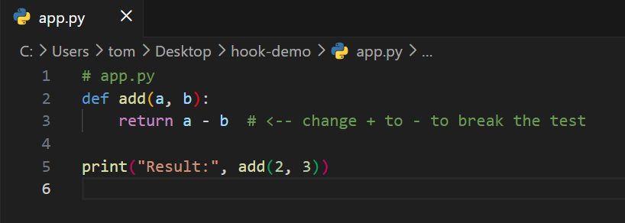
# app.py
def add(a, b):
return a - b # <-- change + to - to break the test

print("Result:", add(2, 3))

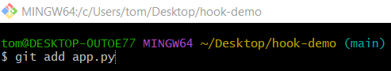
$ git add app.py
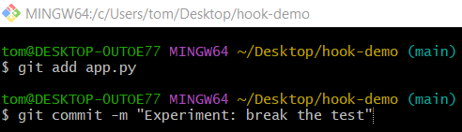
git commit -m "Experiment: break the test"
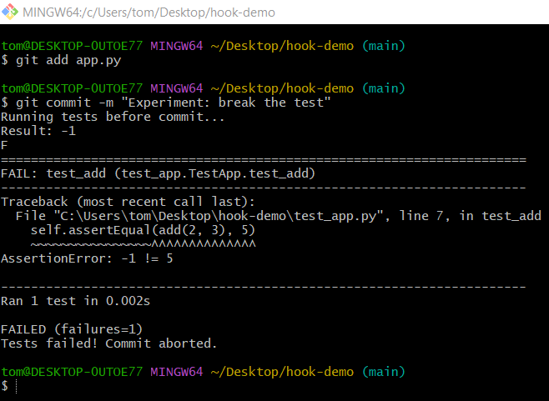

2️⃣ Make the Tests Pass
# Source: ScreenShots Source: Provided by: [Persons Table -> ID Column: 1, Name_En Column: Motasem Essam] -> Tool: [Lightshot Program] -> From [Operating System: Windows] on [3/6/2026]

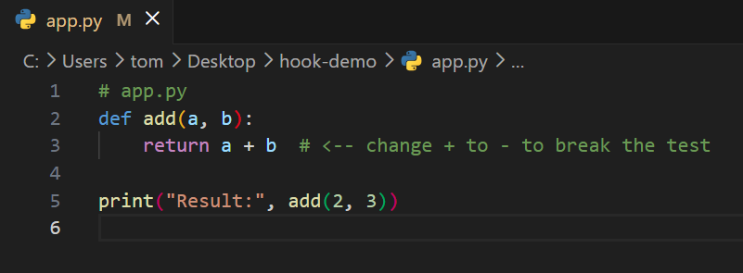
# app.py
def add(a, b):
return a + b # <-- change + to - to break the test

print("Result:", add(2, 3))


$ git add app.py
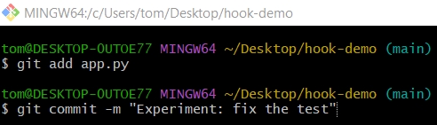
git commit -m "Experiment: fix the test"
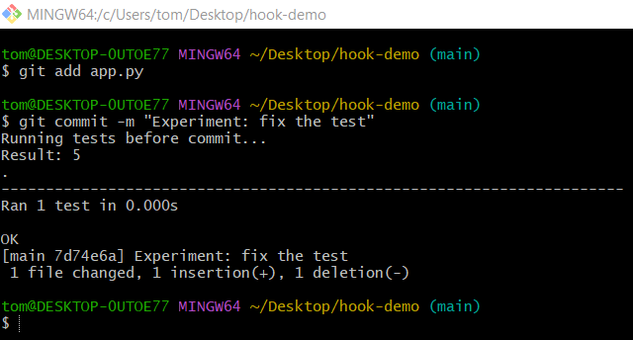

Full step-by-step Husky Test Automation Example

Step 1️⃣ – Create a Project
# Source: ScreenShots Source: Provided by: [Persons Table -> ID Column: 1, Name_En Column: Motasem Essam] -> Tool: [Lightshot Program] -> From [Operating System: Windows] on [3/6/2026]
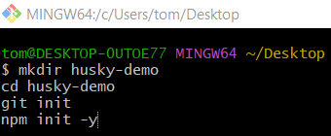
mkdir husky-demo
cd husky-demo
git init
npm init -y
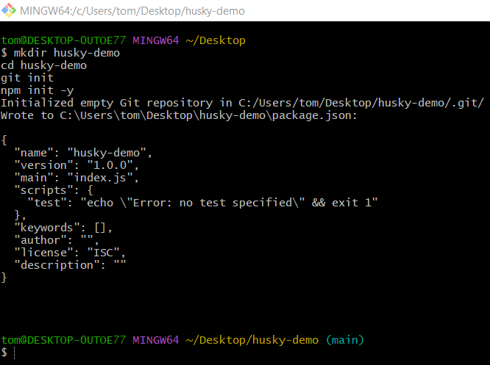

Step 2️⃣ – Install Husky
# Source: ScreenShots Source: Provided by: [Persons Table -> ID Column: 1, Name_En Column: Motasem Essam] -> Tool: [Lightshot Program] -> From [Operating System: Windows] on [3/6/2026]
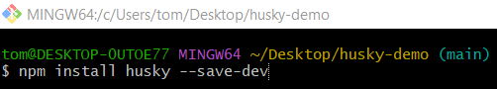
npm install husky --save-dev
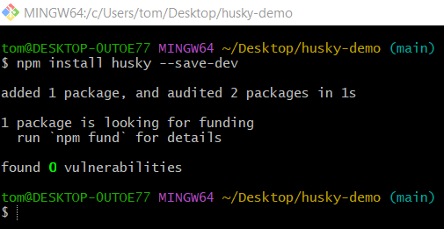

Step 3️⃣ – Enable Husky
# Source: ScreenShots Source: Provided by: [Persons Table -> ID Column: 1, Name_En Column: Motasem Essam] -> Tool: [Lightshot Program] -> From [Operating System: Windows] on [3/6/2026]
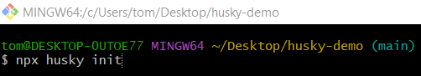
npx husky init
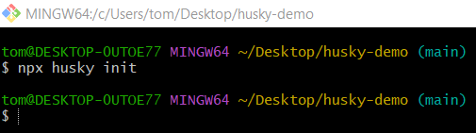

Step 4️⃣ – Install a Test Framework
# Source: ScreenShots Source: Provided by: [Persons Table -> ID Column: 1, Name_En Column: Motasem Essam] -> Tool: [Lightshot Program] -> From [Operating System: Windows] on [3/6/2026]
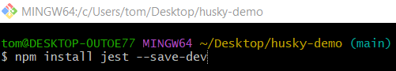
npm install jest --save-dev
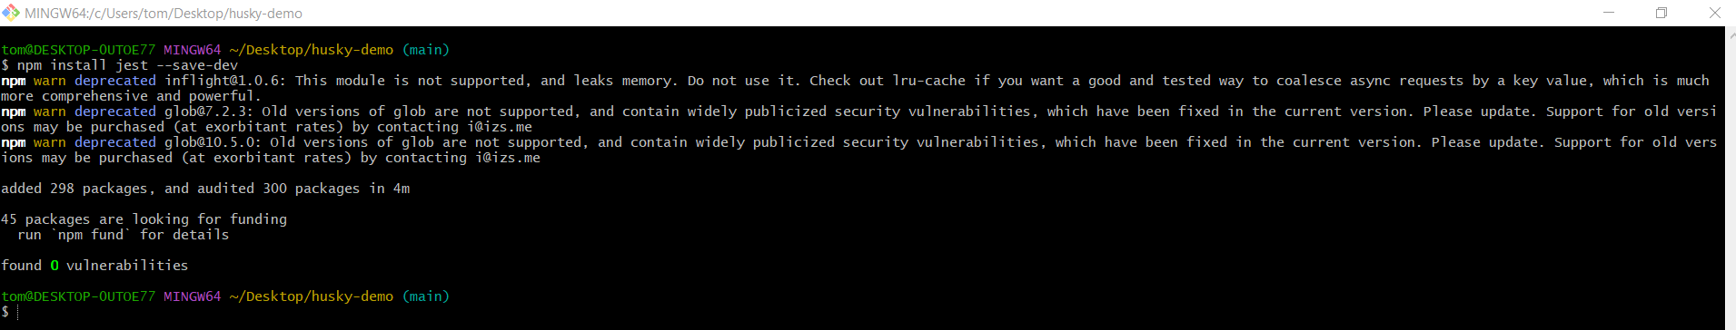
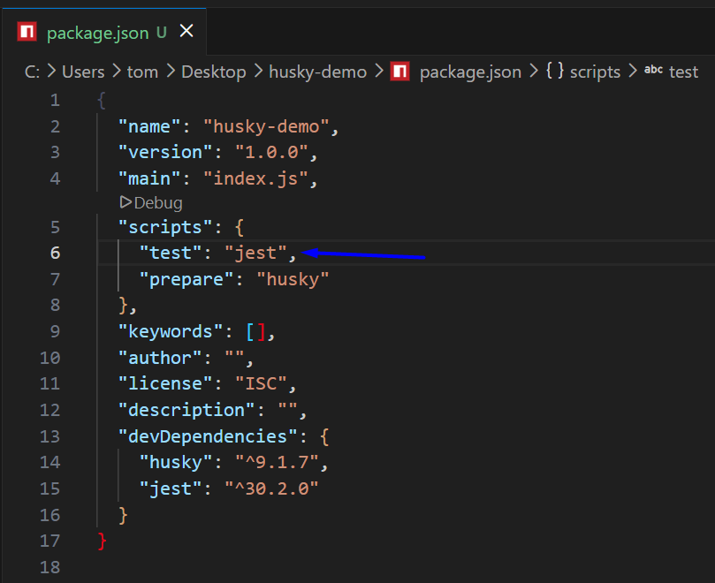
{
"name": "husky-demo",
"version": "1.0.0",
"main": "index.js",
"scripts": {
"test": "jest",
"prepare": "husky"
},
"keywords": [],
"author": "",
"license": "ISC",
"description": "",
"devDependencies": {
"husky": "^9.1.7",
"jest": "^30.2.0"
}
}

Step 5️⃣ Create a Simple Test
# Source: ScreenShots Source: Provided by: [Persons Table -> ID Column: 1, Name_En Column: Motasem Essam] -> Tool: [Lightshot Program] -> From [Operating System: Windows] on [3/6/2026]
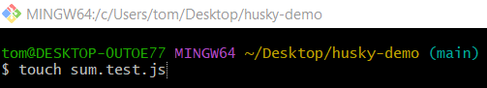
touch sum.test.js
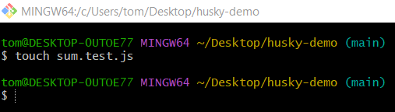
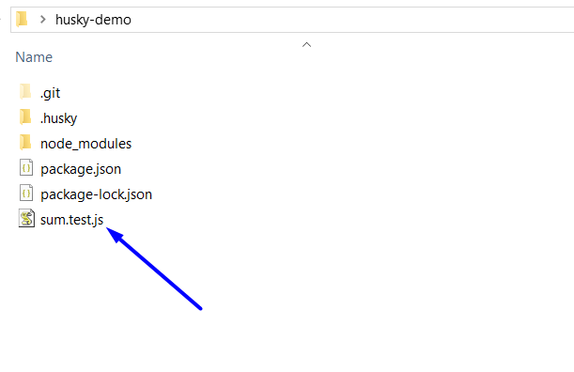
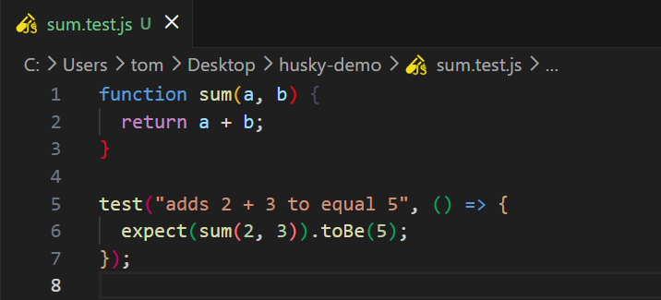
function sum(a, b) {
return a + b;
}

test("adds 2 + 3 to equal 5", () => {
expect(sum(2, 3)).toBe(5);
});

Step 6️⃣ Configure the Pre-commit Hook
# Source: ScreenShots Source: Provided by: [Persons Table -> ID Column: 1, Name_En Column: Motasem Essam] -> Tool: [Lightshot Program] -> From [Operating System: Windows] on [3/6/2026]
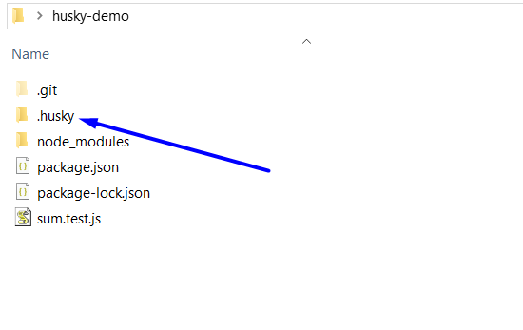
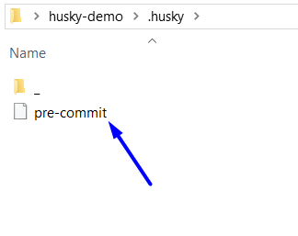
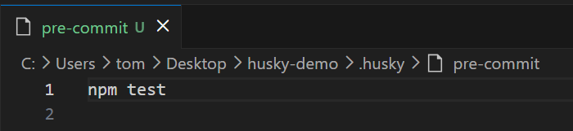

Step 7️⃣ – Experiment (Fail and Pass Tests)

1️⃣ Make the Tests Fail
# Source: ScreenShots Source: Provided by: [Persons Table -> ID Column: 1, Name_En Column: Motasem Essam] -> Tool: [Lightshot Program] -> From [Operating System: Windows] on [3/6/2026]
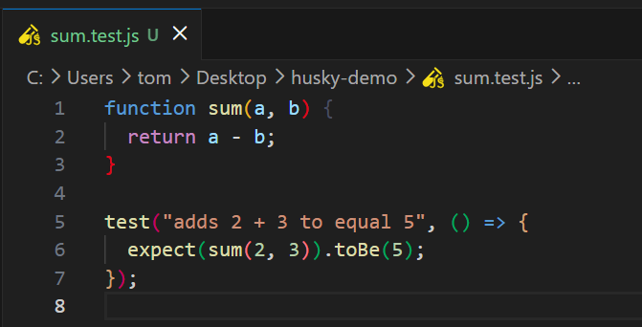
function sum(a, b) {
return a - b;
}

test("adds 2 + 3 to equal 5", () => {
expect(sum(2, 3)).toBe(5);
});

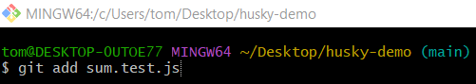
git add sum.test.js
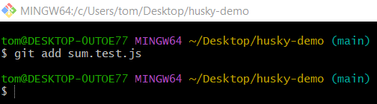
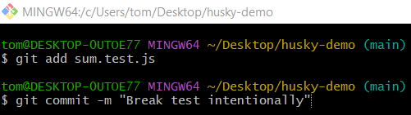
git commit -m "Break test intentionally"
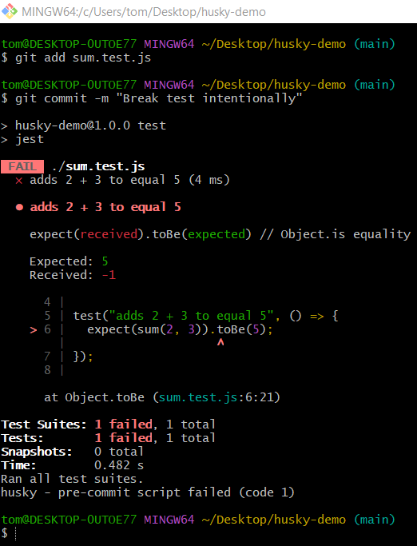

2️⃣ Make the Tests Pass
# Source: ScreenShots Source: Provided by: [Persons Table -> ID Column: 1, Name_En Column: Motasem Essam] -> Tool: [Lightshot Program] -> From [Operating System: Windows] on [3/6/2026]
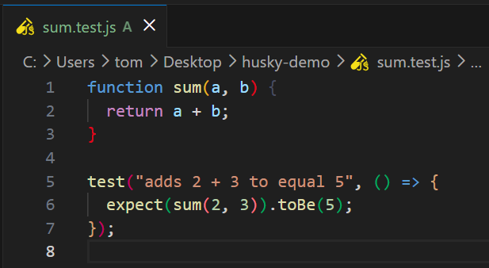
function sum(a, b) {
return a + b;
}

test("adds 2 + 3 to equal 5", () => {
expect(sum(2, 3)).toBe(5);
});


git add sum.test.js

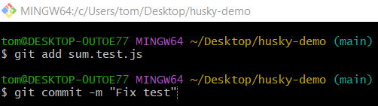
git commit -m "Fix test"
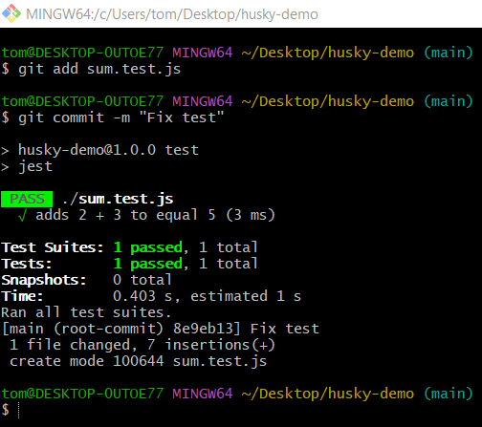

Full Step-by-Step pre-commit Framework Test Automation Example

Step 1️⃣ – Create a Project
# Source: ScreenShots Source: Provided by: [Persons Table -> ID Column: 1, Name_En Column: Motasem Essam] -> Tool: [Lightshot Program] -> From [Operating System: Windows] on [3/6/2026]
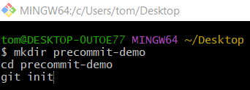
mkdir precommit-demo
cd precommit-demo
git init
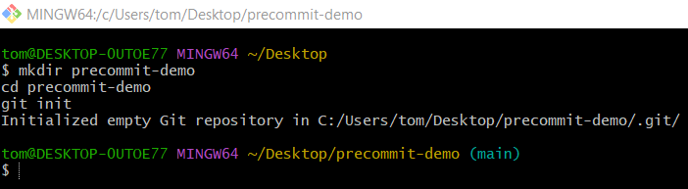

Step 2️⃣ – Install the pre-commit Framework
# Source: ScreenShots Source: Provided by: [Persons Table -> ID Column: 1, Name_En Column: Motasem Essam] -> Tool: [Lightshot Program] -> From [Operating System: Windows] on [3/6/2026]
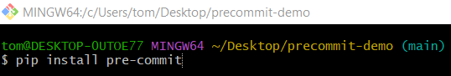
pip install pre-commit
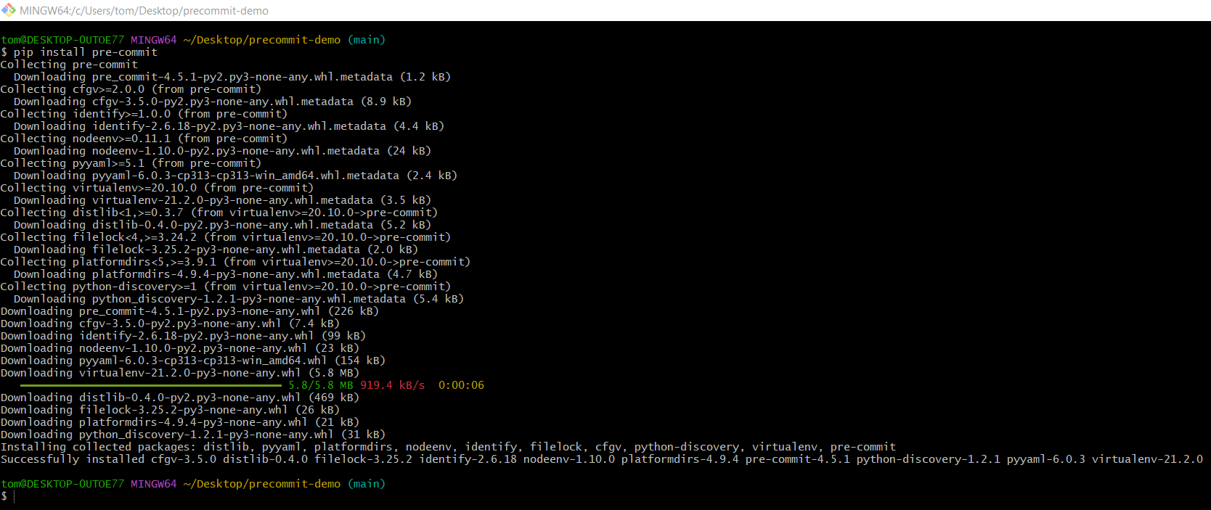

Step 3️⃣ – Create the pre-commit Configuration File
# Source: ScreenShots Source: Provided by: [Persons Table -> ID Column: 1, Name_En Column: Motasem Essam] -> Tool: [Lightshot Program] -> From [Operating System: Windows] on [3/6/2026]
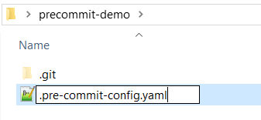
.pre-commit-config.yaml
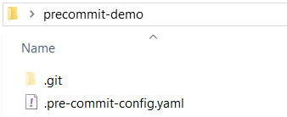
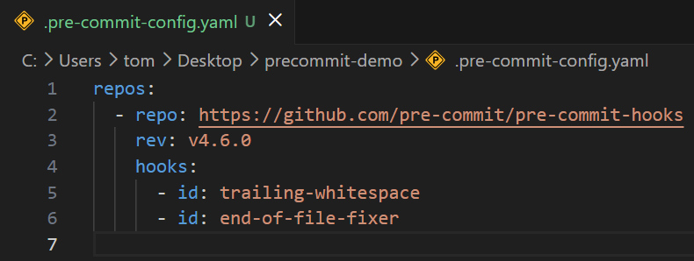
repos:
- repo: https://github.com/pre-commit/pre-commit-hooks
rev: v4.6.0
hooks:
- id: trailing-whitespace
- id: end-of-file-fixer

Step 4️⃣ – Install the Git Hook
# Source: ScreenShots Source: Provided by: [Persons Table -> ID Column: 1, Name_En Column: Motasem Essam] -> Tool: [Lightshot Program] -> From [Operating System: Windows] on [3/6/2026]
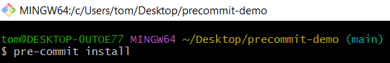
pre-commit install
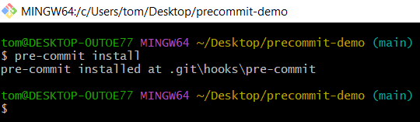

Step 5️⃣ – Create a Simple Python Test
# Source: ScreenShots Source: Provided by: [Persons Table -> ID Column: 1, Name_En Column: Motasem Essam] -> Tool: [Lightshot Program] -> From [Operating System: Windows] on [3/6/2026]
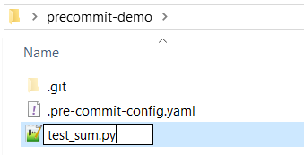
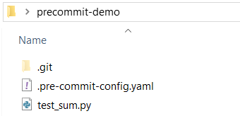
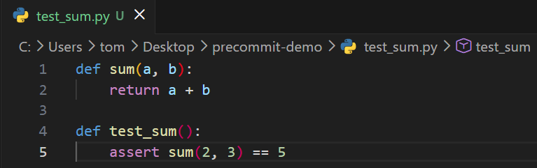
def sum(a, b):
return a + b

def test_sum():
assert sum(2, 3) == 5

Step 6️⃣ – Add a Test Hook
# Source: ScreenShots Source: Provided by: [Persons Table -> ID Column: 1, Name_En Column: Motasem Essam] -> Tool: [Lightshot Program] -> From [Operating System: Windows] on [3/6/2026]
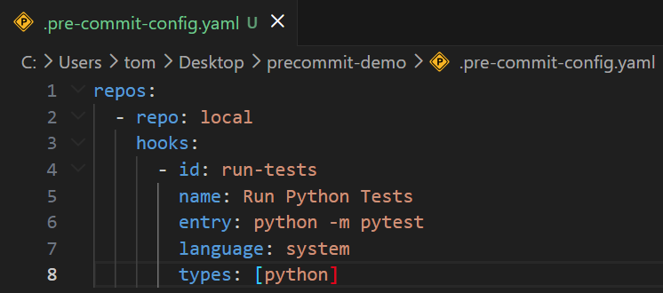
repos:
- repo: local
hooks:
- id: run-tests
name: Run Python Tests
entry: python -m pytest
language: system
types: [python]

Step 7️⃣ – Install Test Tools
# Source: ScreenShots Source: Provided by: [Persons Table -> ID Column: 1, Name_En Column: Motasem Essam] -> Tool: [Lightshot Program] -> From [Operating System: Windows] on [3/6/2026]
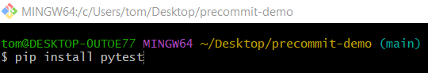
pip install pytest
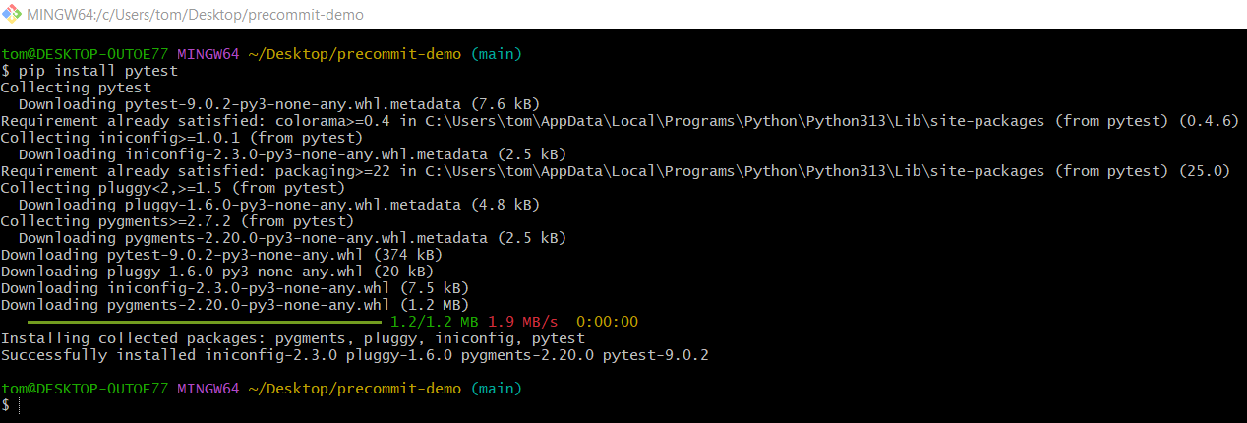

Step 8️⃣ – Experiment (Fail and Pass Tests)

1️⃣ Make the Tests Fail
# Source: ScreenShots Source: Provided by: [Persons Table -> ID Column: 1, Name_En Column: Motasem Essam] -> Tool: [Lightshot Program] -> From [Operating System: Windows] on [3/6/2026]
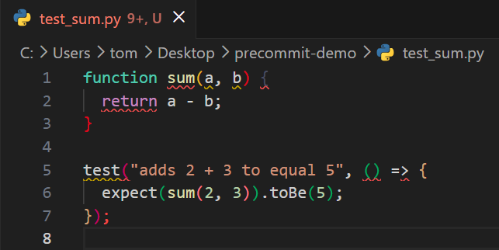
function sum(a, b) {
return a - b;
}

test("adds 2 + 3 to equal 5", () => {
expect(sum(2, 3)).toBe(5);
});
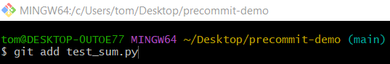
git add test_sum.py
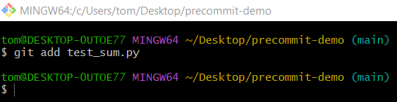
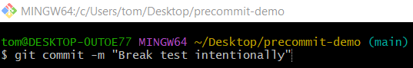
git commit -m "Break test intentionally"
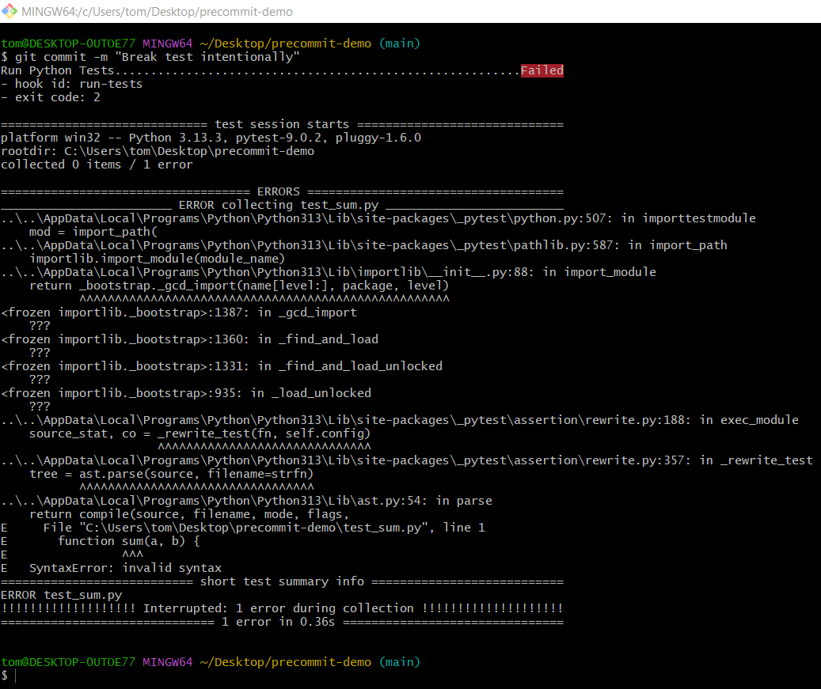

2️⃣ Make the Tests Pass
# Source: ScreenShots Source: Provided by: [Persons Table -> ID Column: 1, Name_En Column: Motasem Essam] -> Tool: [Lightshot Program] -> From [Operating System: Windows] on [3/6/2026]
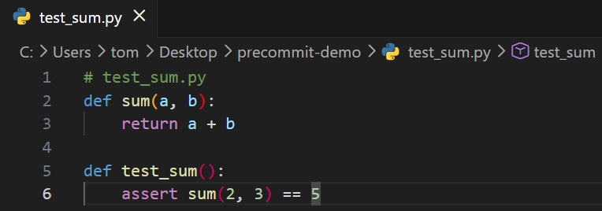
# test_sum.py
def sum(a, b):
return a + b

def test_sum():
assert sum(2, 3) == 5
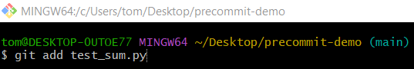
git add test_sum.py
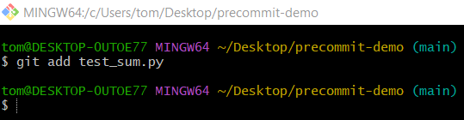
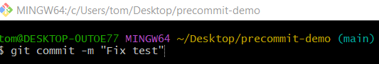
git commit -m "Fix test"
